**1. Table Structure Understanding**

Tables and columns:

* **order_details:**
  + order_details_id (int, PK)
  + order_id (int)
  + pizza_id (text)
  + quantity (int)
* **orders:**
  + order_id (int, PK)
  + order_date (date)
  + order_time (time)
* **pizza_types:**
  + pizza_type_id (text)
  + name (text)
  + category (text)
  + ingredients (text)
* **pizzas:** 
  + pizza_id (text)
  + pizza_type_id (text)
  + size (text)
  + 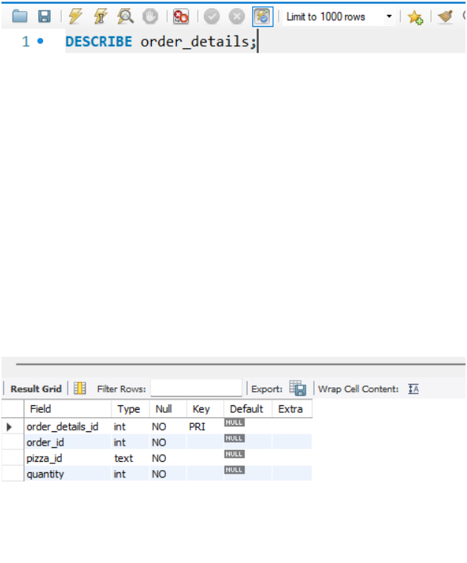price (double)

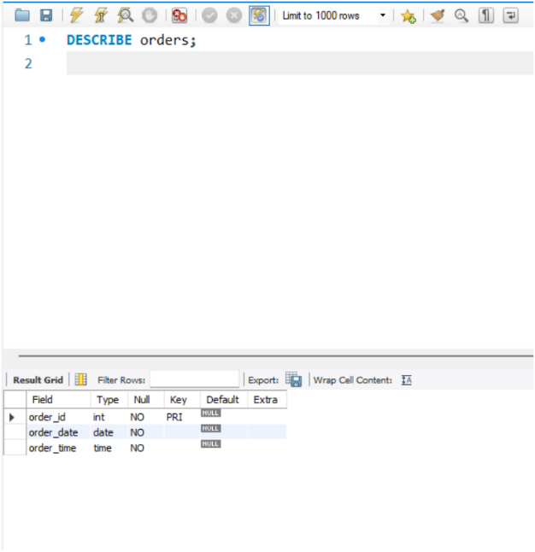

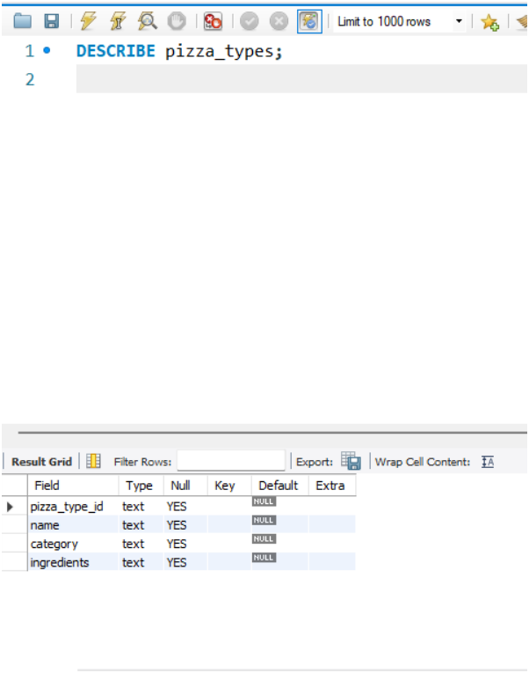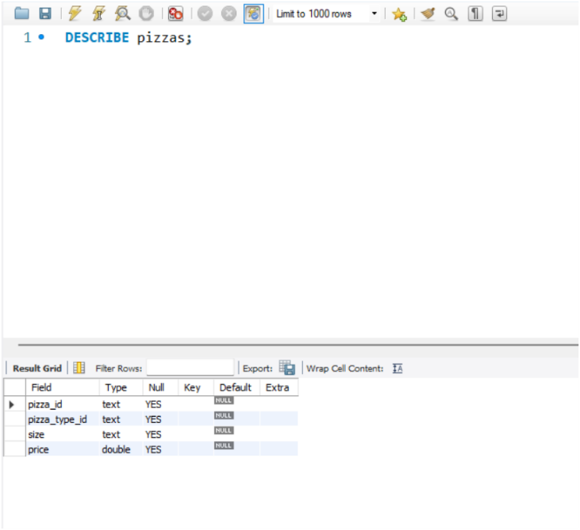

**2. Sample Queries**

**Basic Select**

* View all pizzas and their types:

**Filtering with WHERE**

* Orders on a specific date:

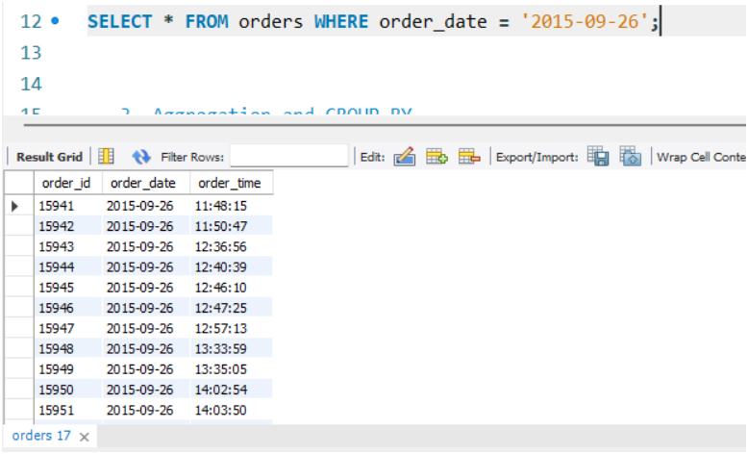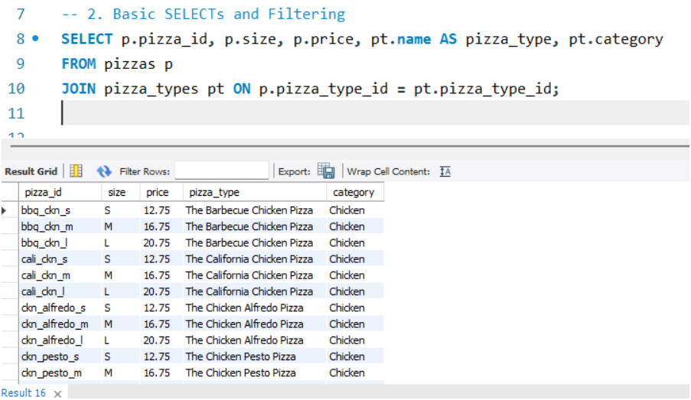

**Aggregation and GROUP BY**

* Total quantity sold per pizza:

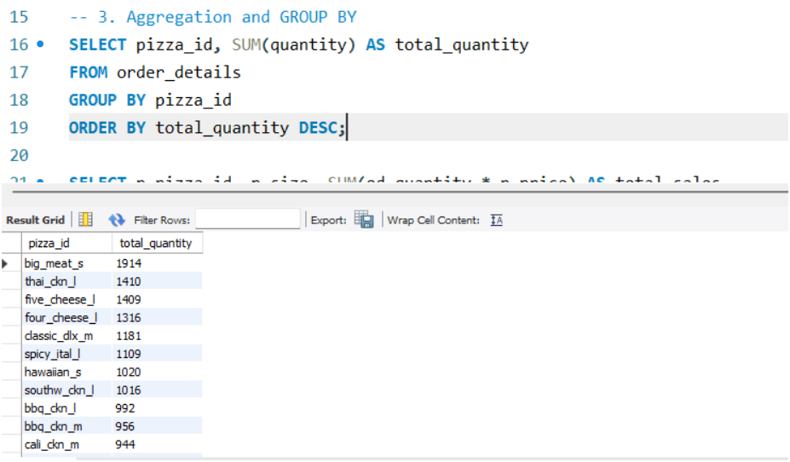

* Total sales amount per pizza (quantity * price):

**Using JOINS**

* Show detailed order info with pizza types and order datetime:

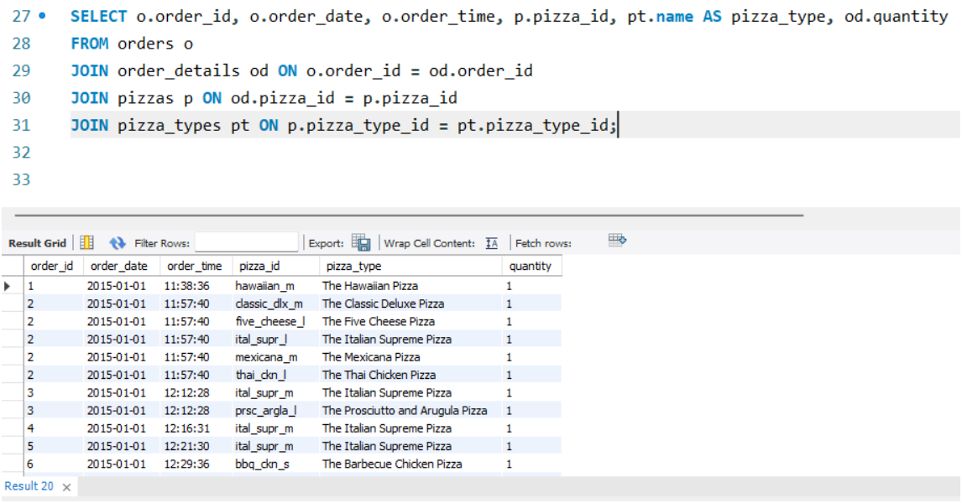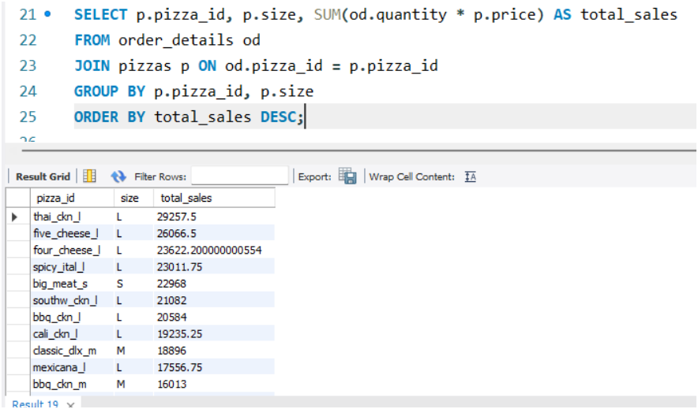

**Subqueries**

* Pizzas sold above average quantity:

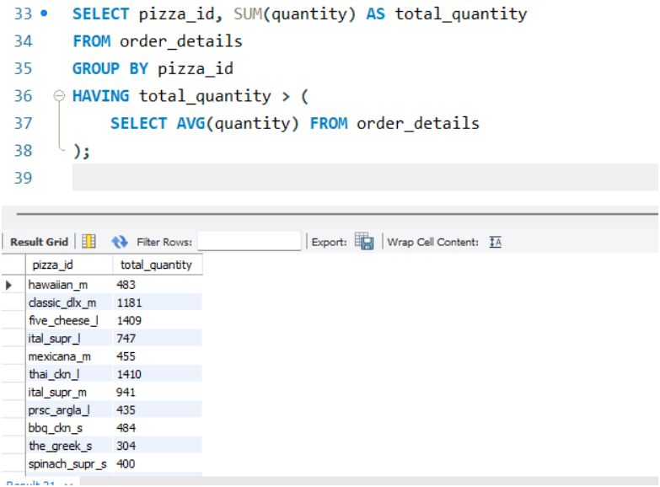

**Views for Repeated Analysis**

Create view for monthly total sales per pizza:

**Index Optimization**

Add indexes to accelerate joins and filters:

